
RAMAIAH
INSTITUTE OF TECHNOLOGY
USN | 1 | M | S

(Autonomous Institute, Affiliated to VTU)
Bangalore – 560 054

SEMESTER END EXAMINATIONS – MAY/JUNE 2017

Course & Branch | : | B.E: Electrical & Electronics Engineering | Semester | : | IV
Subject | : | Signals and Systems | Max. Marks | : | 100
Subject Code | : | EE43 / EE403 | Duration | : | 3 Hrs

Instructions to the Candidates:
- Answer one full question from each unit.

 |  | UNIT-I
1. | a) | Find the even and odd components of each of the following signals.  i) x(t)=cos(t)+sin(t)cos(t) ii) x(t)= 1+tcos(t) | CO1 | (06)
 | b) | Determine whether the system y(n)=x(n)+3u(n+1) is Linear, time invariant, Causal and, Memoryless. | CO1 | (04)
 | c) | A trapezoidal pulse, x(t) defined by  { 5-t, 4  x(t)=  { t+5, - 5  {0, otherwise.  Is the signal power or energy? Find power or energy. Also find the even and odd components of x (t). | CO1 | (10)
2. | a) | Define even and odd signals. Sketch x[n] and its odd and even parts where x[n]= 8(0.5)^{n}u(n). | CO1 | (08)
 | b) | i) Given y(t)= [cos(3πt)]², Check for periodicity. ii) Given y(t) = x(t) + 2 x (3-t), check for causality. Identify the value of t, if any, where the system will change its status from causal to non-causal. | CO1 | (06)
 | c) | Determine whether the signal shown in the Fig. 2(c) is a power signal or energy signal. Justify your answer and further determine its energy or power.  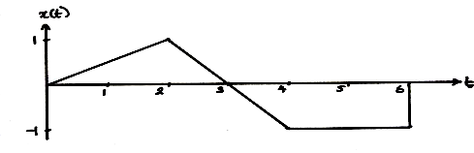  Fig. 2(c) | CO1 | (06)
 |  | UNIT-II
3. | a) | Convolute graphically x(t)& h(t) given in Fig.3(a) and hence plot the output signal.  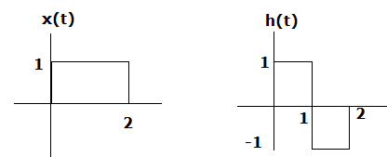  Fig.3(a) | CO2 | (10)
 | b) |  | CO2 | (10)
  Determine the response of the LTI system whose input x(n) and impulse response h(n)are given by x(n)=3^{n}u(-n) and h(n)=u(n). Plot y(n).
4. | a) | Given x(t)= e^{-at} ;0< t < T and h(t) = 1 ; 0< t < 2T. Obtain the convolution integral graphically. | CO2 | (10)
 | b) | Compute the convolution of two sequences x₁(n) and x₂(n), given below. x₁(n)={ 1,2,3} and x₂(n)={ 1,2,3,4} | CO2 | (10)
 |  | UNIT-III
5. | a) | For the system given below, find the total response  Y(n) =5/6 Y(n-1)-1/6 Y(n-2)+x[n]-x[n-1] where x[n]=2^{n}u[n]  Y(-1)= 0, Y(-2)= 1. | CO4 | (12)
 | b) | Draw direct form I and direct form II structure of the following  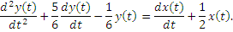 | CO4 | (08)
6. | a) | Determine the complete response of the systems | CO2 | (12)
 | b) | Explain: i) sampling theorem ii) Complete response of an LTT system. | CO2 | (08)
 |  | UNIT-IV
7. | a) | Determine the response of the LTT system whose input x(n) and impulse response h(n)are given by x(n)={1,2,3,1} and  h(n)={ 1,2,1,-1} using Discrete Time Fourier Transform. | CO4 | (10)
 | b) | List out the properties of DTFT. | CO4 | (10)
8. | a) | The impulse response of an LTI system is given by h(n)= 0.6^{n} U(n). Find the frequency response. | CO4 | (12)
 | b) | Determine the DTFT of the following signal 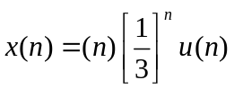 | CO4 | (08)
 |  | UNIT- V
9. | a) | Find the Z transform and ROC of i)(-1)^{n} 2^{-n} u(n)  ii) x(n)=n[(1/2)^{n}u(n) * (1/2)^{n}u(n)], where * symbol indicates convolution. | CO5 | (08)
 | b) | Solve the following difference equation using unilateral Z Transform  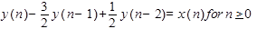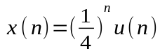  with initial conditions y(-1)=4,and y(-2) = 10. | CO5 | (12)
10. | a) | A causal discrete time LTI system has to be designed with the property that if the input x(n)= (1/2)^{n}u(n) – ¼ (1/2)^{n-1}u(n-1), the corresponding output should be y(n)= (1/3)^{n}u(n). Determine the impulse response h(n) and the transfer function H(Z) that satisfies this condition. | CO5 | (10)
 | b) | Find the inverse Z transform of:  X(Z)= 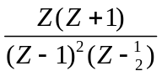, ROC |Z| | CO5 | (10)
****************

